Software Requirements Document

Treasure Box Braille Authoring Application

**EECS 2311 Group 3**

**1. Introduction**

This section will give an overview of the product, its scope, potential use cases and acceptance cases.

**1.1 Purpose**

The purpose of this application is to be a tool to view, edit and create scenarios for the Treasure Box Braille (TBB) device. Through it, clients will be able open and edit existing TBB scenario files, and create new ones from scratch.

The target audience for this project are primarily teachers and educators of visually impaired

students. The program will function as a tool for them to dynamically teach students braille through TBB scenarios.

**1.2 Scope**

The “Treasure Box Braille Authoring Application” is a desktop application which enables users to view, edit and create scenarios for the TBB in an intuitive and simple way. The scope of the project is as follows:

• View TBB scenarios that are in .txt format

• Identify if a text file is a TBB scenario

• Edit existing TBB scenarios that are in .txt format

• Save any changes made to an existing TBB scenario

• Create new TBB scenarios

• Save any created TBB scenarios as a text file that can later be reopened

• Test existing or created TBB scenarios using a software simulator

• Record audio

• Have accessibility support for visually impaired users

Mobile support is not planned at this point in time. Accessibility support is only available if the user has a screen reader already installed.

**1.3 Use Cases**

• Teachers creating scenarios for visually impaired students as a way to learn braille

• A dynamic way to create scenarios for teaching braille

• Viewing and editing existing scenario files

• Writing books/text in braille for those who are visually impaired

**1.4 Acceptance Test Cases:**

• Successfully opens and correctly displays a scenario text file

• Allows editing and saving of an imported scenario text file

• Throws error if imported file is not a scenario file

• New scenario files can be created, edited and saved

• Scenario files can be tested using virtual TBB

• Record audio from a user

• Usable by someone who is visually impaired

**2. Specific Requirements**

This section describes the functional and quality requirements of the TBB Authoring Application. It contains detailed descriptions of the system’s features.

**2.1 User Interfaces**

A user opening the Authoring Application should be presented with a window containing the

following buttons:

• Create Scenario

• Import Scenario

• Export Scenario

• (Greyed out) Test Scenario

• Create Audio File

See Figure 1.

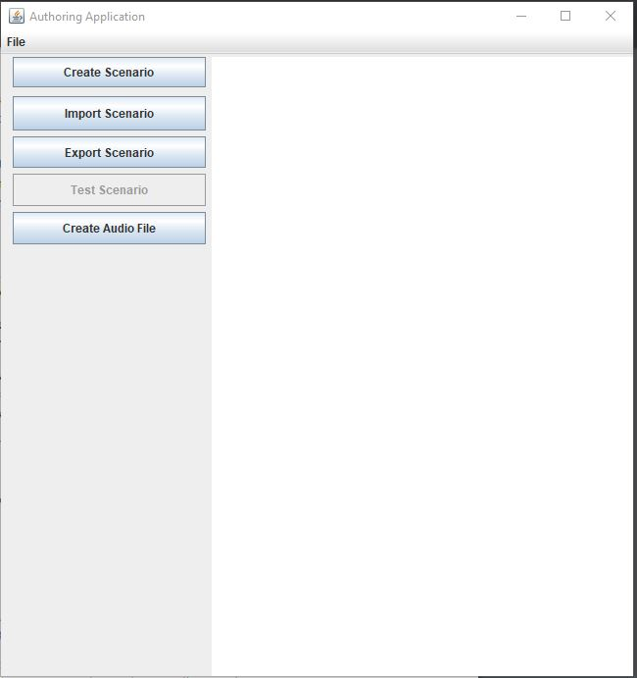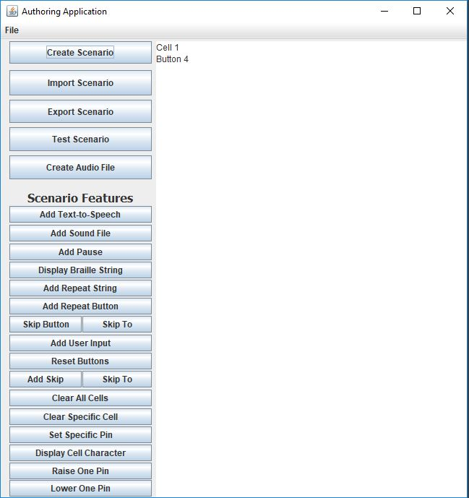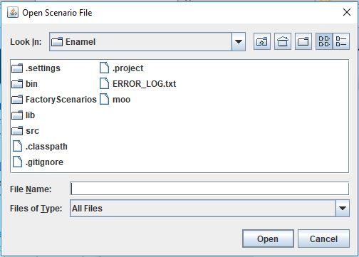

Figure 1 - Opening Page Figure 2 - Scenario Features Panel Figure 3 – Importing/Exporting Files

**2.1.1 Create Scenario**

If the Create Scenario button is selected, the user should be prompted to first enter the number of TBB cells they are using, then the number of buttons they would like to include in their scenario. After both of these inputs are completed the application will update to show the Scenario

Features panel (see Figure 2), which is used to add new elements to the scenario. The Test

Scenario button should become active.

**2.1.2 Import Scenario**

If the Import or Export Scenario buttons are selected, a new window should open, allowing them to select the file they wish to import, or the location to export the scenario as a text file (.txt) to (see Figure 3). Once a Scenario file is imported, the Test Scenario button should become active.

**2.1.3 Test Scenario**

If the Test Scenario button is selected, the application should test whatever the current content is (either an imported or created scenario). It should run the scenario through a virtual TBB

Simulator for the user to verify that this is the desired output.

**2.1.4 Create Audio**

If the Create Audio button is selected, the user should be prompted to enter the name of the audio file they wish to create and the duration of the audio file in seconds. Recording will start after they press yes to the confirmation shown after the previous two values are entered correctly. If they press no, a message should appear verifying that the recording was cancelled.

**2.2 Functional Requirements**

This section contains descriptions of the required features of the system.

**2.2.1 View TBB scenarios that are in .txt format**

A user should be able to import and view existing TBB scenarios that are in .txt format.

**2.2.2 Identify if a text file is a TBB scenario**

Given that the user has imported a .txt file, the application should recognize if the formatting of the .txt file is an acceptable TBB scenario.

**2.2.3 Edit existing TBB scenarios that are in .txt format**

Given that the user has imported a TBB scenario into the application, they should be able to make changes to the scenario.

**2.2.4 Save any changes made to an existing TBB scenario**

Given that the user has imported a TBB scenario and made changes to it, they should be able to save the changed TBB scenario as a text file.

**2.2.5 Create new TBB scenarios**

A user should be able to create a new TBB scenario using the given tools and buttons that is able to utilize all of the features of the TBB.

**2.2.6 Save any created TBB scenarios as a text file that can later be reopened**

Given that a user has created a TBB scenario, they should be able to save the scenario as a text file in the correct format.

**2.2.7 Test existing or created TBB scenarios using a software simulator**

Given that a user has imported or created a TBB scenario, they should be able to test the scenario using a built-in TBB software simulator to see if it functions as expected.

**2.2.8 Record audio**

The application should be able to record audio from a microphone that is connected to the computer. This is so that a user can add custom audio to a scenario.

**2.2.9 Have accessibility support for visually impaired users**

Given that a user is visually impaired and have a screen reader compatible with java accessibility support, they should be able to use the application to it’s full capability.